Title: “A Case of Suspected Urea Cycle Dysfunction in a Patient with Non-hepatic Hyperammonemia”

Authors:
Christopher Perrone, BS^{1*}
Monica Makhija, MD^{1*}
Ann Mitchell, MD¹
¹Department of Neurology, University of Massachusetts Medical School, Worcester, MA, USA
*co-first authorship

Email addresses for correspondence:
Christopher.Perrone@umassmed.edu
makhijma@hotmail.com
Ann.Mitchell@umassmemorial.org

Keywords: Hyperammonemic encephalopathy, urea cycle, inborn errors of metabolism, CPSI, OTC

Classification: Case Report

Abstract
Objective: To report a case of fatal hyperammonemia from an adult onset hereditary urea cycle defect.

Case Summary: A 48-year-old woman with a history of bulimia and bipolar disorder presented with a four week history of confusion and lethargy in the setting of a twenty-pound weight loss. Shortly after presentation, she deteriorated and became obtunded. Brain MRI was consistent with hypoxic-ischemic injury, but the patient had not been observed to experience episodes of hypotension or desaturation during her deterioration. With an elevated ammonia level discovered in the setting of normal liver function tests on admission and no response to lactulose, non-hepatic causes of hyperammonemia were considered.

Discussion: The patient’s acute presentation initially led to a metabolic panel that was notable for low citrulline and arginine levels but with a normal orotic acid level. We propose that she exhibited an ornithine transcarbamylase (OTC) or carbamoyl phosphate synthetase (CPS) deficiency. Genetic testing and liver biopsy were inconclusive.

Conclusion: This case highlights the importance of early consideration of inborn errors of metabolism in adults presenting with non-hepatic hyperammonemia

Introduction

Urea cycle disorders are inherited deficiencies of the enzymes and transport molecules involved in the cellular excretion of excess ammonia produced during protein metabolism. Hyperammonemia associated with these disorders is usually manifested by decreased level of consciousness, irritability, seizures, vomiting and poor feeding. Although the majority of affected patients are children, a delayed presentation is seen in patients with partial enzyme deficiency, including heterozygotes. These patients become symptomatic in later childhood or adulthood. Diagnoses of urea cycle defects (UCD) in the adult population have been reported (11). Often, the diagnosis only becomes apparent during times of increased metabolic stress, such as with acute or chronic illness. Prompt recognition and treatment are essential in determining the outcome of these patients. We present a case of hyperammonemic encephalopathy from a presumed urea cycle defect.

Case Report

We report a case of a 48-year-old woman with a history of bulimia and bipolar disorder who presented with a four week history of confusion and lethargy in the setting of a twenty-pound weight loss. Per family, the patient began to exhibit poor recall and personality changes over the course of a year and had begun to lose weight over the previous 6 months. In the week prior to admission, she had been speaking very little and was consuming only fluids. In the ER, she was minimally responsive and appeared poorly groomed. She had an initial lumbar puncture that was normal. Her head CT showed scattered, patchy, ill-defined hypodensities in the white matter in both cerebral hemispheres, more than expected for the patient’s age. Initial laboratory studies demonstrated a low bicarbonate level, consistent with a non-anion gap metabolic acidosis, for which she was placed on bicarbonate drip. Her B12, folate, thiamine, TSH and toxicology screen were unremarkable with the exception of an ammonia level of 371. There was no other evidence of liver failure. As a part of her treatment, she was given multiple doses of lactulose but failed to improve clinically. Genetics was consulted for a suspected urea cycle defect. She was treated with scavenger agents (sodium phenyl acetate and sodium benzoate). Her ammonia level improved to the normal range within 24 hours.
Shortly after the patient's arrival, the patient experienced three episodes of non-sustained ventricular tachycardia. These episodes did not result in medically significant hypotension or desaturation, however the patient deteriorated clinically and became obtunded. She was noted to have roving eye movements and posturing of all four limbs. The patient received heavy sedation and anticonvulsants for presumed status epilepticus, which was later confirmed by EEG. Her neurological exam was compromised by heavy sedation, but she did have a minimal gag reflex, but no other brainstem reflexes, no elicitable response to pain, and no response to plantar stimulation bilaterally. Initial MRI brain revealed diffuse restricted diffusions in bilateral insular lobes and cerebral cortex, suggestive of hypoxic-ischemic injury.
Her acute clinical decompensation and high ammonia prompted extensive work up of her nutritional status, including amino acid deficiencies. Other causes of acute hyperammonemia in adults were considered, such as malignancy, multiple myeloma and valproate-induced hyperammonemia. Her immunofixation revealed an IgA lambda monoclonal band, but there was no evidence of multiple myeloma or cancer. Her valproate level was less than 10, making this etiology unlikely. Less common causes, such as inborn and acquired errors of metabolism, were further investigated. A low carnitine level in the setting of hyperammonemia, a high creatine kinase (peripheral metabolism), a high triglyceride level (ketosis), and low BUN (2-3) supported a metabolic defect. A quantitative amino acid panel was obtained. Taurine, hydroxyproline, proline, threonine, serine, glycine,alanine, citrulline, valine, methionine, isoleucine, leucine, tyrosine, phenylalanine, and arginine were observed to be low. Aspartic acid, cystine, lysine, and histidine were normal. Glutamine and ornithine were elevated. The patient’s amino acid panel (low citrulline, low arginine) indicated that she most likely had an ornithine transcarbamylase (OTC) or carbamoyl phosphate synthase (CPS) dysfunction. However, the patient did not exhibit orotic aciduria to support OTC deficiency and genetic testing from a liver biopsy failed to reveal any mutations to support CPS deficiency.
Test | Result | Reference
Taurine | 18 µmol/L (L) | 25-80
Aspartic Acid | 10 µmol/L | 0-20
Hydroxyproline | 46 µmol/L | 6-50
Threonine | 100 µmol/L | 60-220
Serine | 56 µmol/L (L) | 60-200
Allo-isoleucine | 0 µmol/L | 0
Homocystine QBAA | 0 µmol/L | 0
Glutamic Acid | 46 µmol/L | 10-120
Glutamate | 1054 µmol/L (H) | 410-700
Proline | 521 µmol/L (H) | 110-500
Glycine | 224 µmol/L | 140-490
Alanine | 283 µmol/L | 240-600
Citrulline | 20 µmol/L | 10-60
Valine | 88 µmol/L (L) | 140-350
Cystine | 12 µmol/L | 7-70
Methionine | 10 µmol/L (L) | 17-53
Isoleucine QBAA | 13 µmol/L (L) | 30-130
Leucine | 35 µmol/L (L) | 60-230
Tyrosine | 17 µmol/L (L) | 30-120
Phenylalanine | 23 µmol/L (L) | 30-80
Ornithine QBAA | 82 µmol/L | 20-135
Lysine | 234 µmol/L | 80-250
Histidine | 96 µmol/L | 50-130
Arginine | 27 µmol/L (L) | 40-160

Follow-up MRI demonstrated decreased intensity in previously noted areas and no new lesions, leading to the hypothesis that MRI findings were the result of hyperammonemia rather than due to global hypoxic-ischemic injury (Figure 3a). Related to this finding, MR spectroscopy demonstrated peaks most strongly for glutamine rather than lactate, supporting glutamate toxicity as a result of a urea cycle defect as opposed to hypoxic-ischemic injury (Figure 3b). Genetic testing failed to identify mutations for CPSI or OTC deficiency, which are the most commonly occurring genetic deficiencies. However, with the inability to detect variant polymorphisms as well as large deletions and duplications, the possibility of a urea cycle defect was still the likely diagnosis. Due to the patient's poor neurological prognosis, the patient's family transitioned the patient to comfort measures only and she was terminally extubated.

Discussion

As described by our case, the presence of hyperammonemia in the setting of normal liver enzymes studies raises the possibility of an inborn error of metabolism. Typically, with the urea cycle, ammonia is incorporated into an amino acid at each enzymatic step; accordingly, one ammonium ion is removed at each step until urea is formed. Deficiency in any five of the enzymes in the cycle, results in the accumulation of ammonia which could be potentially fatal if untreated (8). Although usually seen in neonates, later cases of childhood and adulthood have been described (11). The presentation is atypical, with chronic vomiting, developmental delay, seizure disorder, sleep disorders, or psychiatric illnesses following increased protein intake or during periods of stress such as acute or chronic illness (11). The most common deficiencies are ornithine transcarbamylase (OTC) or carbamoyl phosphate synthetase (CPS) deficiency, both of which have an enzyme defect early in the urea cycle. The OTC patients will display a low citrulline and arginine level in the metabolic panel. The urine studies typical show a high level of orotic acid, which is a by-product of the cycle and is made from carbamoyl phosphate when OTC is not available. OTC is an X-linked disorder and can have a late presentation from carrier states in which there are varying amounts of residual enzyme activity (11). The amount of organic acids (orotic acids) in the urine may be difficult to detect in these patients because of the varying degree of enzymatic activity (lyonization) (8). The OTC gene has been found to exhibit enormous variation. More than 340 mutations have been identified in families in which there was clinical OTC deficiency (9). A patient with CPS deficiency (autosomal recessive) would likely demonstrate mutation of the CPSI gene. However, the possibility of this condition cannot be excluded, as transcriptional regulation of CPS expression by benign variants or polymorphisms is possible and the genetic testing does not detect large heterozygous deletions or duplications, or mutations within the promoter or deep intronic regions (5).
An early recognition of the toxic effects of hyperammonemia and investigation into etiology are critical for prognosis. If untreated, patients may develop intracerebral hypertension, subclinical seizures (40% of cases) and eventually cerebral herniation and fatal outcome (8). Our patient’s symptoms of confusion, lethargy, and weight loss are consistent with a progressive hyperammonemic state. Further, quantitative evidence of continual elevation of ammonia was found. Response to treatment with sodium phenylacetate and sodium benzoate (ammonia scavenging agents) in patients with urea cycle dysfunction can potentially reverse the toxic effects of ammonia. This patient’s ammonia level was reduced to the normal range within 24 hours, and she exhibited radiographic improvement (FIGURE 3a/3b). Hyperammonemia of this etiology that is treated promptly has a good prognosis. Urea cycle defects are treatable with low-protein diet, amino acid supplementation, and/or liver transplant (7). Unfortunately, in this case, because of prolonged toxicity, the patient’s status epilepticus could not be resolved and she suffered a fatal outcome. Our case provides emphasis that early recognition of hyperammonemic encephalopathy without evidence of liver failure should prompt investigation for a UCD.

Summary

Although most commonly associated with infancy, urea cycle defects should be considered in adults with hyperammonemic encephalopathy. The signs and symptoms may be vague and atypical but patients may present with recurrent and fulminant presentations. Specific metabolic testing and enzymatic or molecular confirmation are necessary to establish the diagnosis but may not always be possible due to presently still undescribed mutations. Early recognition and treatment with medication, dietary protein restrictions and/or liver transplant can improve long term outcome.

Figure 3a: Diffusion weighted restricted MRI Figure 3b: FLAIR MRI
10/21 10/28 10/22 10/30
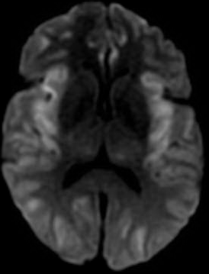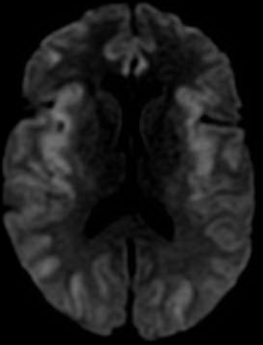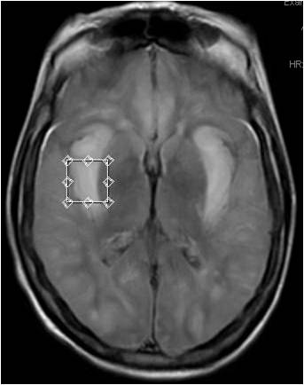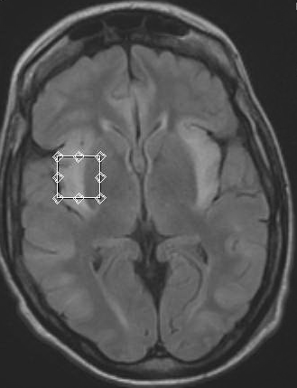

References:
1.Niemi AK & Enns GM. Pharmacology review: Sodium phenylacetate and sodium benzoate in the
treatment of neonatal hyperammonemia. Neoreviews. 2006, 7: E486.
2.Clay AS & Hainline BE. Hyperammonemia in the ICU. Chest. Oct 2007;132(4):1368-78.
3.U-King-Im JM, Yu E, Bartlett E, Soobrah R, Kucharczyk W. Acute hyperammonemic encephalopathy in
adults: Imaging findings. AJNR. Feb 2011;32:413-18.
4.Bachmann C & Colombo JP. Diagnostic value of orotic acid excretion in heritable disorders of the urea
cycle and in hyperammonemia due to organic acidurias. Eur J Pediatr. 1980;134:109-113.
5.Takeoka M, Soman TB, Shih VE, Caviness VS Jr, Krishnamoorthy KS. Carbamyl phosphate synthetase
1 deficiency: A destructive encephalopathy. Pediatr Neurol. 2001 Mar;24(3):193-9.
6.Enns GM, Berry SA, Berry GT, Rhead WJ, Brusilow SW, Hamosh A. Survival after treatment with
phenylacetate and benzoate for urea-cycle disorders. N Engl J Med. May 2007;356(22):2282-92.
7.Batshaw ML & Monahan PS. Treatment of urea cycle disorders. Enzyme. 1987;3
8. Bega D, Vaitkevicius H, Boland TA, Murray M, Chou SH. Fatal hyperammonemic brain injury from valproic acid exposure. Case Rep Neurol. 2012 Sep;4(3):224-30. doi: 10.1159/000345226. Epub 2012 Dec 11
9. Lien J, Nyhan WL, Barshop BA. Fatal initial adult-onset presentation of urea cycle defect. Arch Neurol. 2007 Dec;64(12):1777-9.
10. Gardeitchik T, Humphrey M, Nation J, Boneh A. Early clinical manifestations and eating patterns in patients with urea cycle disorders. J Pediatr. 2012 Aug;161(2):328-32. doi: 10.1016/j.jpeds.2012.02.006. Epub 2012 Mar 16
11. Smith W, Kishnani PS, Lee B, Singh RH, Rhead WJ, Sniderman King L, Smith M, Summar M.
Urea cycle disorders: clinical presentation outside the newborn period. Crit Care Clin. 2005 Oct;21(4 Suppl):S9-17.
12. Atiq M, Holt AF, Safdar K, Weber F, Ravinuthala R, Jonas ME, Neff GW. Adult onset urea cycle disorder in a patient with presumed hepatic encephalopathy. J Clin Gastroenterol. 2008 Feb;42(2):213-4.

